Week 5 Final Assignment

Brandon M. Korell
UAGC
CST 499: Computer Software Technology
Charmelia Butler
12/8/2025

1. Introduction
1.1 Purpose
The purpose of this Software Requirements Specification (SRS) is to define the functional and non-functional requirements of the Course Enrollment System created for the CST499 capstone project. This document describes how users create accounts, log in, browse available courses, enroll in courses, view their schedule, and drop courses. The SRS guides the design, implementation, testing, and evaluation of the system.
1.2 Scope
The Course Enrollment System is a web-based application developed using PHP, MySQL, HTML, Bootstrap, and XAMPP. The system enables students to register accounts, log in securely, access course listings, enroll in classes, view their active enrollments, and delete courses from their schedule.
This project simulates a simplified university enrollment system for academic demonstration purposes.
1.3 Intended Users
- Students: Create accounts, authenticate, enroll in courses, view schedules, and remove courses.
- Instructor / Developers: Review the implementation, verify functionality, test system accuracy, and assess documentation.
1.4 System Overview
The system contains the following primary pages:
Page | Description
index.php | Landing page with login and registration buttons
register.php | User account creation
login.php | User authentication
dashboard.php | Main student home page
courses.php | List of all available courses and enrollment options
myclasses.php | Displays a user's enrolled courses
logout.php | Ends the user session
Data is stored in a MySQL database containing user records, course listings, and enrollment associations.

2. System Requirements
2.1 Functional Requirements
2.1.1 User Registration
The system shall:
- Allow users to enter full name, email address, and password.
- Hash passwords with password_hash() before storage.
- Prevent duplicate email registration.
- Redirect users to the login page upon successful registration.
2.1.2 User Login
The system shall:
- Authenticate users by email and password.
- Verify passwords with password_verify().
- Create a secure session upon successful login.
- Display an error message for invalid credentials.
2.1.3 Session Management
The system shall:
- Require an active session for all protected pages.
- Redirect unauthorized users to the login page.
- Provide a logout link to destroy the session.
2.1.4 View Available Courses
The system shall:
- Retrieve all course records from the database.
- Display course name, course code, and description.
- Provide an “Enroll” button next to each course.
2.1.5 Enroll in Courses
The system shall:
- Allow students to enroll in selected courses.
- Store enrollments in the enrollments table.
- Prevent duplicate enrollment for the same course and user.
2.1.6 View Enrolled Courses
The system shall:
- Display all courses the student is currently enrolled in.
- Provide a “Drop” button for each listed course.
2.1.7 Drop a Class
The system shall:
- Remove the enrollment record when a student drops a course.
- Update the enrollment list immediately.

3. Non-Functional Requirements
3.1 Security
- Passwords must be stored as hashed strings.
- All database operations must use prepared statements.
- Sessions must be used to secure user-specific pages.
3.2 Usability
- All pages must use Bootstrap for consistent styling.
- Navigation shall include a universal header with links and a logout option.
- Pages must be easy to navigate for first-time users.
3.3 Performance
- Each page must load within 2 seconds under normal local hardware.
- Database queries must execute within 1 second.
3.4 Reliability
- The system shall prevent duplicate enrollments.
- The system shall maintain stable database connectivity via PDO error handling.

4. Database Requirements
4.1 Tables
4.1.1 users Table
Field | Type | Description
id | INT AUTO_INCREMENT | Primary key
full_name | VARCHAR(100) | Student's full name
email | VARCHAR(100), UNIQUE | Student email
password_hash | VARCHAR(255) | Hashed password
4.1.2 courses Table
Field | Type | Description
id | INT AUTO_INCREMENT | Primary key
course_name | VARCHAR(100) | Course title
course_code | VARCHAR(10) | Unique course identifier
description | TEXT | Course description
4.1.3 enrollments Table
Field | Type | Description
id | INT AUTO_INCREMENT | Primary key
user_id | INT | Foreign key - users.id
course_id | INT | Foreign key - courses.id

5. Use Cases
5.1 UC-01: Register Account
Actor: Student
Description: A student submits registration information.
Postcondition: Account is created and user is redirected to login.
5.2 UC-02: Login
Actor: Student
Description: User provides email and password to authenticate.
Outcome: Successful login redirects user to dashboard.
5.3 UC-03: Enroll in Course
Actor: Student
Description: Student selects a course to enroll in.
Outcome: Enrollment is stored in the database.
5.4 UC-04: View My Classes
Actor: Student
Description: System retrieves and displays all enrolled courses.
5.5 UC-05: Drop Class
Actor: Student
Description: Student removes a course from schedule.
Outcome: Enrollment record is deleted.

6. System Constraints
- Application must run on XAMPP with PHP 8+ and MySQL.
- System is intended for localhost execution only.
- No administrator roles are implemented.

7. Assumptions
- Students are the only user type.
- Course catalog is manually populated via phpMyAdmin.
- Users have basic web browsing experience.

8. Glossary
- Enrollment: A stored association between a user and a course.
- Session: PHP mechanism for tracking authenticated users.
- PDO: PHP Data Objects for secure database communication.

9. UML Diagrams
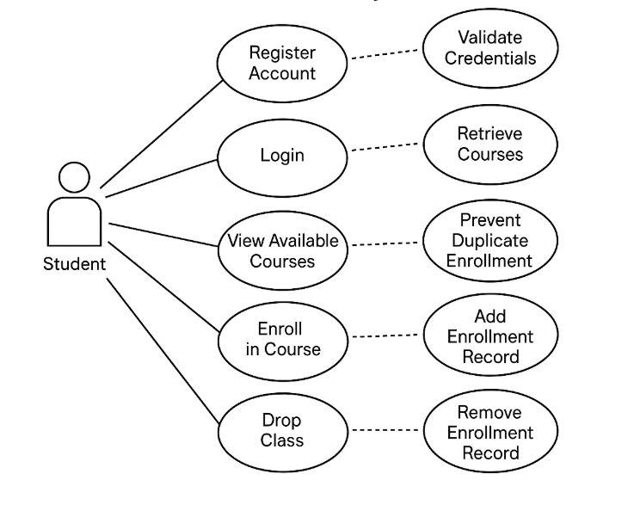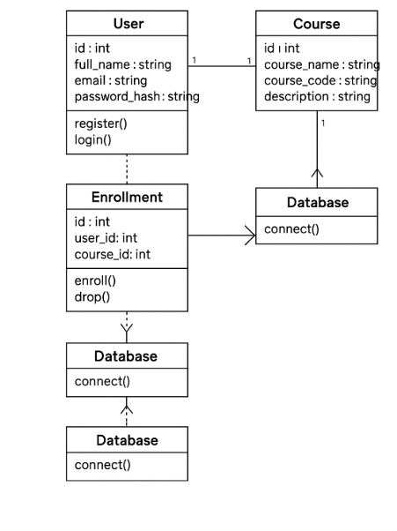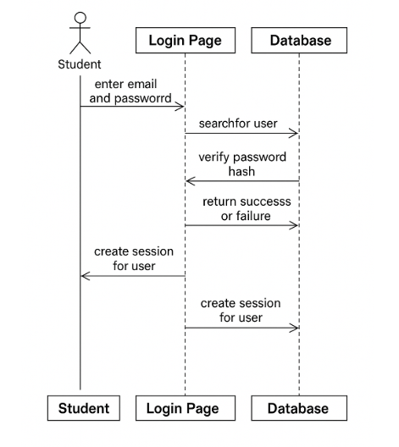
10. Images
